**Report for Designation page of Organization Module**

This is how Our main page looks:

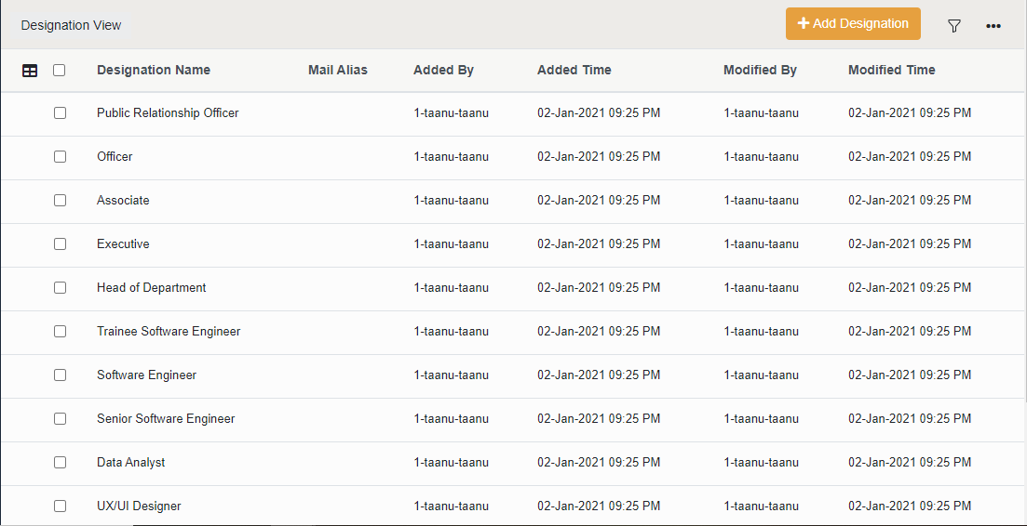

When Clicked of “Funnel Icon” A Bootstrap Modal opens and display relevant options.

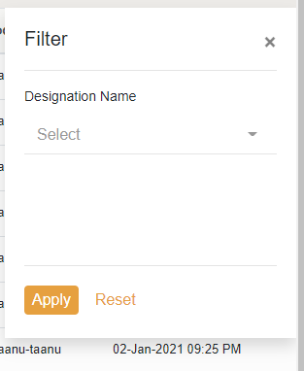

When clicked on “table icon” a dropdown opens with column names in it and search option.

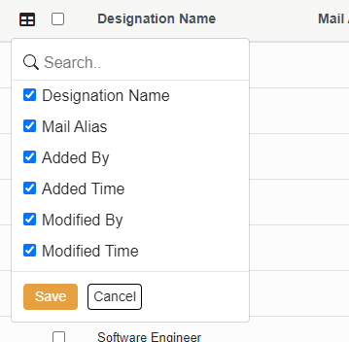

Whatever checkbox is checked those rows will only be made visible.

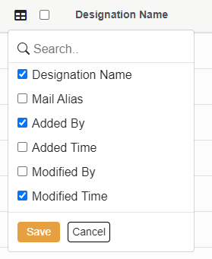

For the above configurations, we have the view show below.

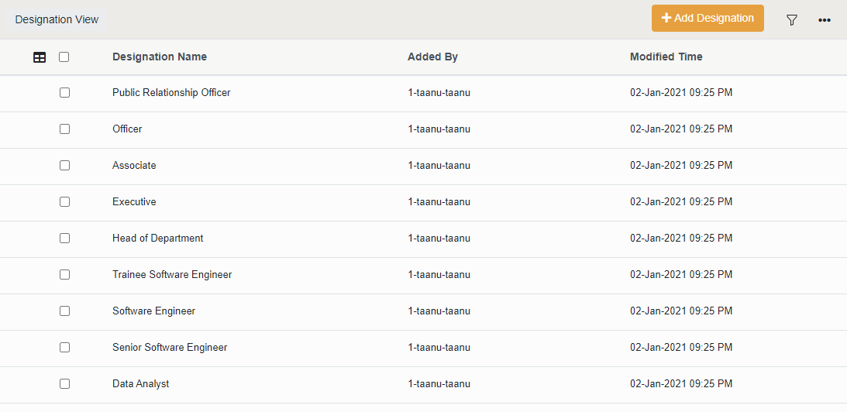

When Hovered over the rows of data rows an icon will appear on left of that row.

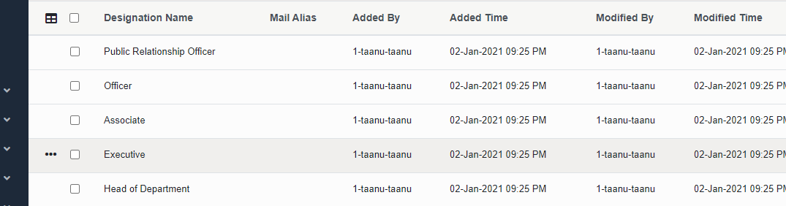

These icons will enable dropdown for each of those rows as shown below

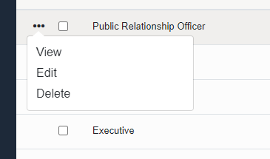

When clicked on any checkbox that are present on rows of table, delete option will appear at top of table.

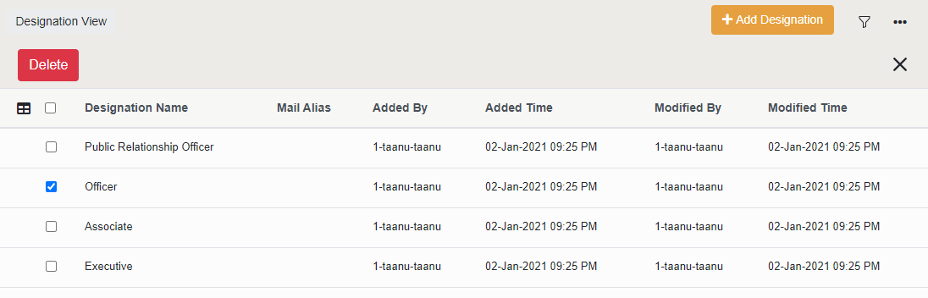

When pressed delete modal opens up and if confirmed then the selected row gets deleted and delete button row will be disappeared

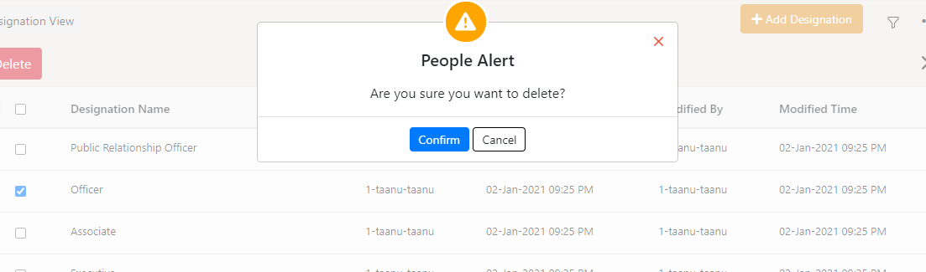

But instead if we chose to close or cancel instead of confirm the delete row get hidden and checkbox will be unchecked.

No of records at the end of page gets updated according to the number of rows in table



Onclick of Add Designation a modal opens from right to left on the respective page height and width.

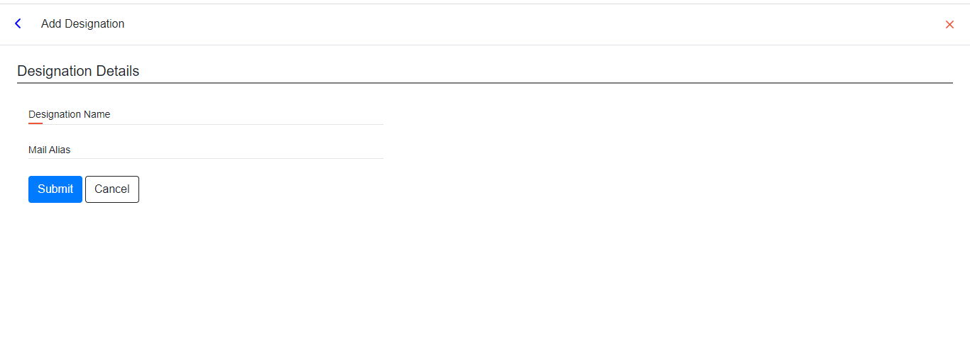

On click of any label or input field the line below input box turns blue.



On click of submit, cancel button and cross icon, form data will be cleared and modal gets closed.

To customize the view of table we have

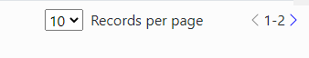

We can select the number of records that should be displayed at a moment and we can make use of left and right button to accesses through records of table

The icon gets disabled when you don’t have any more records

These things change according to number of records we have, so if we delete some rows of table number of pages also changes